COS20019
Cloud Computing Architecture
Truong Ngoc Gia Hieu
105565520
Week 3 – ACF Lab 2:
Build a VPC and launch a Web Server
Lab 2: Build your VPC and Launch a Web Server
A. Lab overview and objectives

In this lab, you will use Amazon Virtual Private Cloud (VPC) to create your own VPC and add additional components to produce a customized network. You will also create a security group. You will then configure and customize an EC2 instance to run a web server and you will launch the EC2 instance to run in a subnet in the VPC.

Amazon Virtual Private Cloud (Amazon VPC) enables you to launch Amazon Web Services (AWS) resources into a virtual network that you defined. This virtual network closely resembles a traditional network that you would operate in your own data center, with the benefits of using the scalable infrastructure of AWS. You can create a VPC that spans multiple Availability Zones.
After completing this lab, you should be able to do the following:
- Create a VPC.
- Create subnets.
- Configure a security group.
- Launch an EC2 instance into a VPC.

Duration
This lab takes approximately 30 minutes to complete.

AWS service restrictions
In this lab environment, access to AWS services and service actions might be restricted to the ones that are needed to complete the lab instructions. You might encounter errors if you attempt to access other services or perform actions beyond the ones that are described in this lab.

Scenario
In this lab you build the following infrastructure:
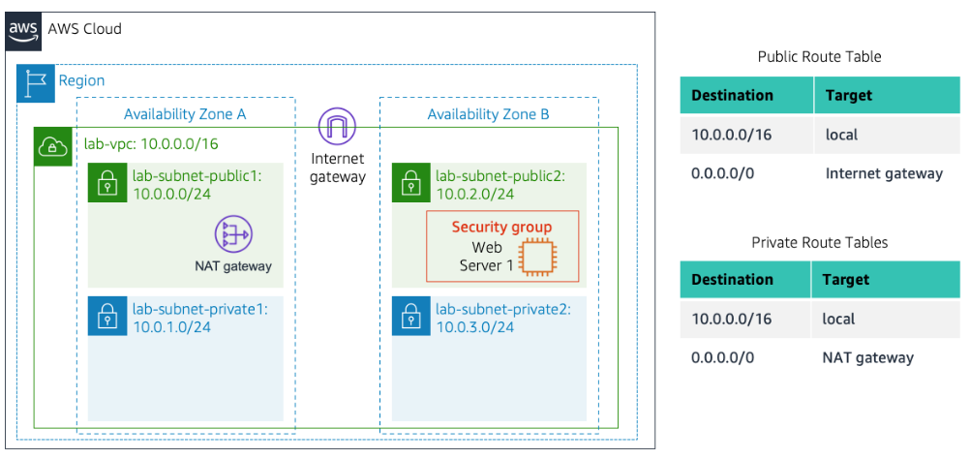
Accessing the AWS Management Console
- At the top of these instructions, choose Start Lab.
  - The lab session starts.
  - A timer displays at the top of the page and shows the time remaining in the session.
Tip: To refresh the session length at any time, choose Start Lab again before the timer reaches 0:00.
  - Before you continue, wait until the circle icon to the right of the AWS link in the upper-left corner turns green.
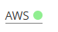
Figure 1: AWS Console Home Activated

- To connect to the AWS Management Console, choose the AWS link in the upper-left corner.
  - A new browser tab opens and connects you to the console.
Tip: If a new browser tab does not open, a banner or icon is usually at the top of your browser with the message that your browser is preventing the site from opening pop-up windows. Choose the banner or icon, and then choose Allow pop-ups.

- Arrange the AWS Management Console tab so that it displays along side these instructions. Ideally, you will be able to see both browser tabs at the same time, to make it easier to follow the lab steps.

Getting Credit for your work
At the end of this lab you will be instructed to submit the lab to receive a score based on your progress.
Tip: The script that checks you works may only award points if you name resources and set configurations as specified. In particular, values in these instructions that appear in This Format should be entered exactly as documented (case-sensitive).

B. Task 1: Create Your VPC
In this task, you will use the VPC and more option in the VPC console to create multiple resources, including a VPC, an Internet Gateway, a public subnet and a private subnet in a single Availability Zone, two route tables, and a NAT Gateway.

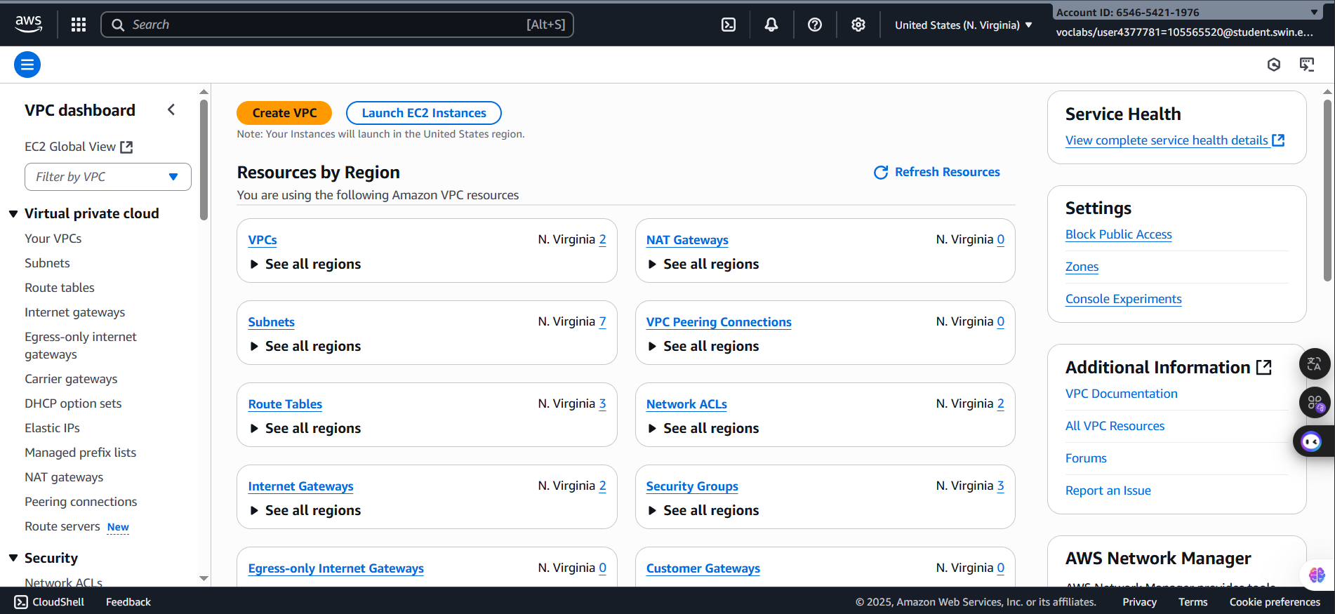
4. In the search box to the right of Services, search for and choose VPC to open the VPC console.

Figure 2: VPC Homepage
5. Begin creating a VPC.
- In the top right of the screen, verify that N. Virginia (us-east-1) is the region.
- Choose the VPC dashboard link which is towards the top left of the console.

- Next, choose .
Note: If you do not see a button with that name, choose the Launch VPC Wizard button instead.

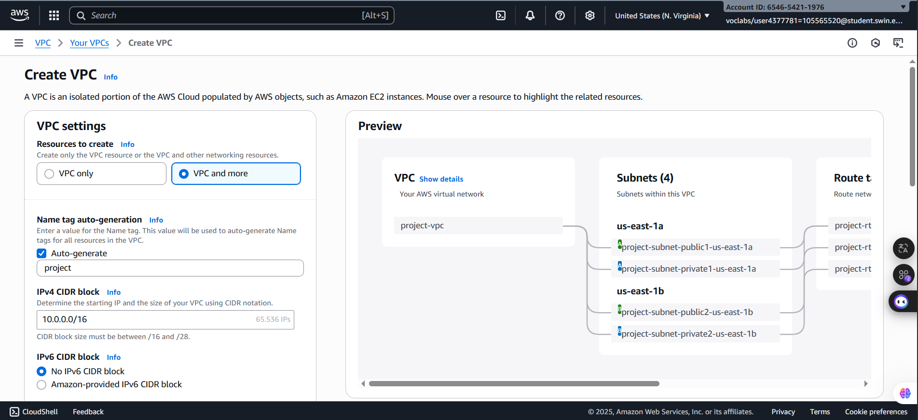
Figure 3: VPC Configurations page
6. Configure the VPC details in the VPC settings panel on the left:
- Choose VPC and more.
- Under Name tag auto-generation, keep Auto-generate selected, however change the value from project to lab.
- Keep the IPv4 CIDR block set to 10.0.0.0/16
- For Number of Availability Zones, choose 1.
- For Number of public subnets, keep the 1 setting.
- For Number of private subnets, keep the 1 setting.
- Expand the Customize subnets CIDR blocks section
  - Change Public subnet CIDR block in us-east-1a to 10.0.0.0/24
  - Change Private subnet CIDR block in us-east-1a to 10.0.1.0/24
- Set NAT gateways to In 1 AZ.
- Set VPC endpoints to None.
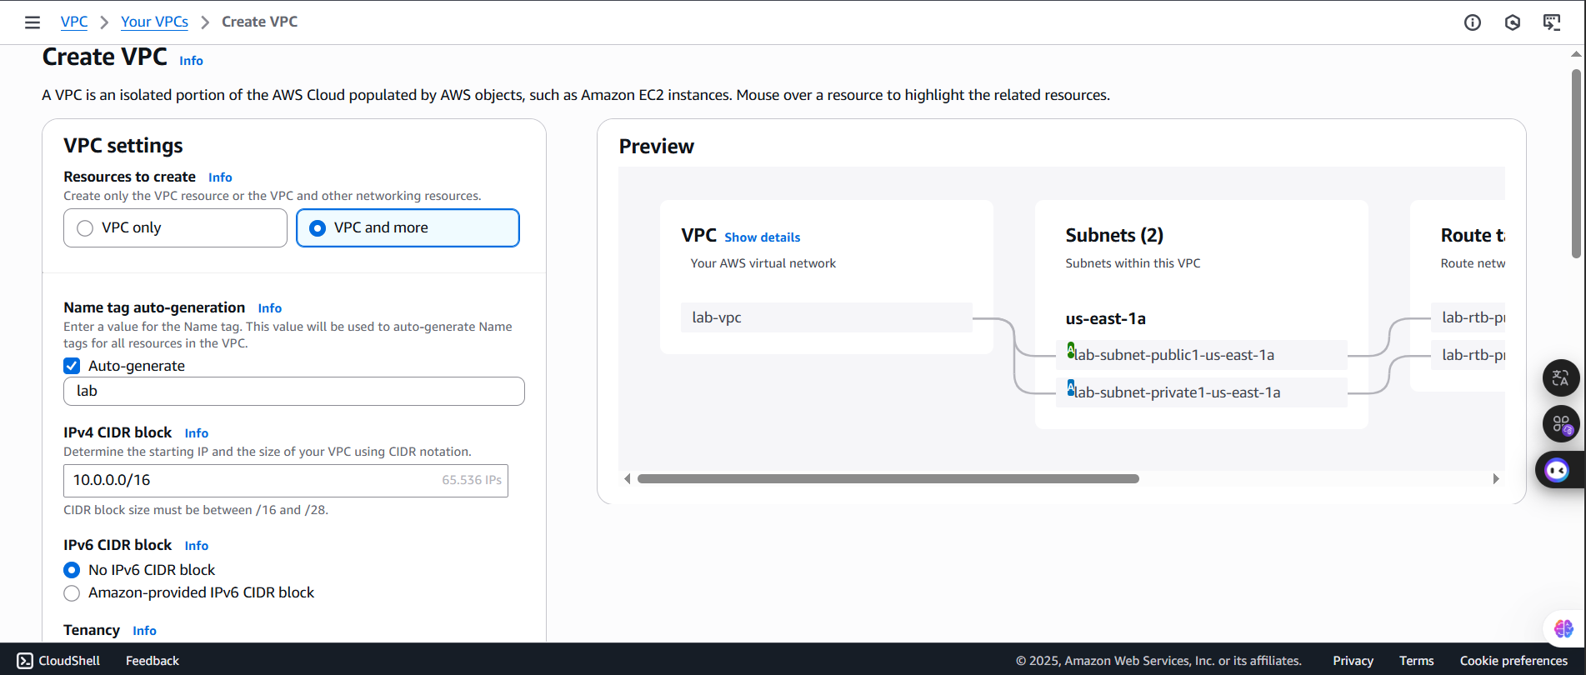
- Keep both DNS hostnames and DNS resolution enabled
Figure 4: VPC settings

7. In the Preview panel on the right, confirm the settings you have configured.
- VPC: lab-vpc
- Subnets:
- us-east-1a
- Public subnet name: lab-subnet-public1-us-east-1a
- Private subnet name: lab-subnet-private1-us-east-1a
- Route tables
- lab-rtb-public
- lab-rtb-private1-us-east-1a
- Network connections
- lab-igw
- lab-nat-public1-us-east-1a


8. At the bottom of the screen, choose
The VPC resources are created. The NAT Gateway will take a few minutes to activate.
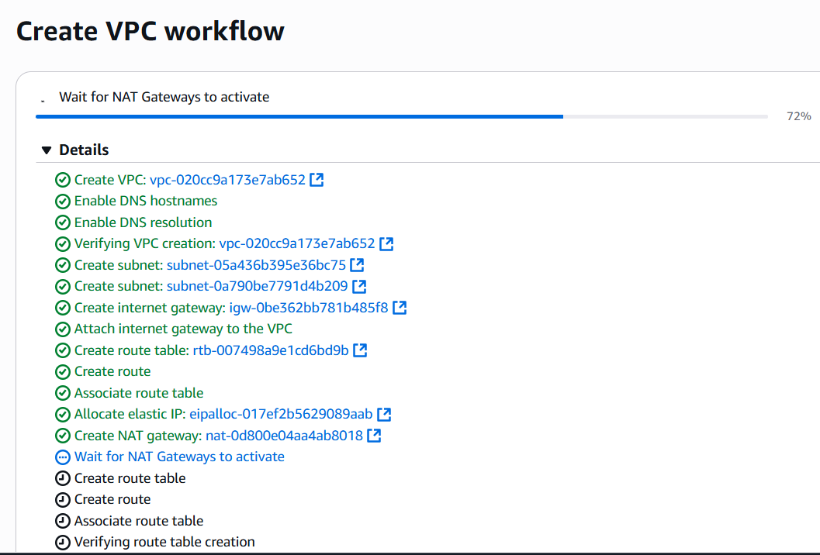
Please wait until all the resources are created before proceding to the next step.

Figure 5: Setting

9. Once it is complete, choose
The wizard has provisioned a VPC with a public subnet and a private subnet in one Availability Zone with route tables for each subnet. It also created an Internet Gateway and a NAT Gateway.
To view the settings of these resources, browse through the VPC console links that display the resource details. For example, choose Subnets to view the subnet details and choose Route tables to view the route table details. The diagram below summarizes the VPC resources you have just created and how they are configured.
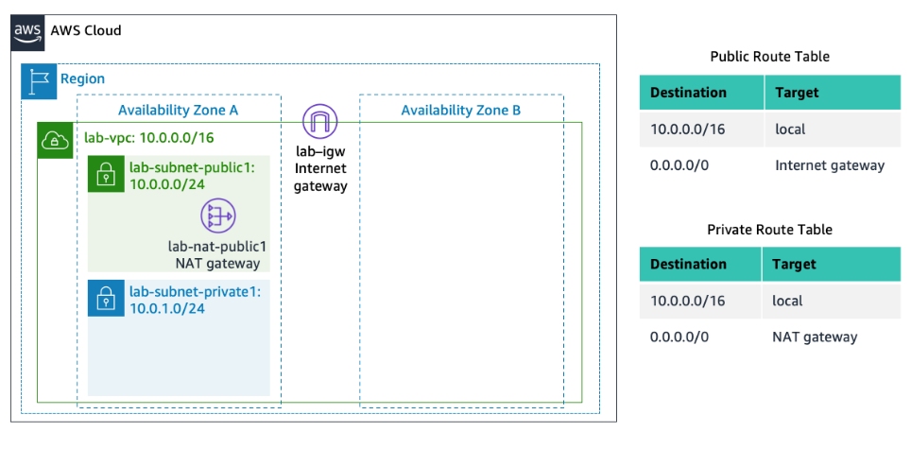
An Internet gateway is a VPC resource that allows communication between EC2 instances in your VPC and the Internet.

The lab-subnet-public1-us-east-1a public subnet has a CIDR of 10.0.0.0/24, which means that it contains all IP addresses starting with 10.0.0.x. The fact the route table associated with this public subnet routes 0.0.0.0/0 network traffic to the internet gateway is what makes it a public subnet.

A NAT Gateway, is a VPC resource used to provide internet connectivity to any EC2 instances running in private subnets in the VPC without those EC2 instances needing to have a direct connection to the internet gateway.

The lab-subnet-private1-us-east-1a private subnet has a CIDR of 10.0.1.0/24, which means that it contains all IP addresses starting with 10.0.1.x.
C. Task 2: Create Additional Subnets
In this task, you will create two additional subnets for the VPC in a second Availability Zone. Having subnets in multiple Availability Zones within a VPC is useful for deploying solutions that provide High Availability.
After creating a VPC as you have already done, you can still configure it further, for example, by adding more subnets. Each subnet you create resides entirely within one Availability Zone.

10. In the left navigation pane, choose Subnets.
First, you will create a second public subnet.

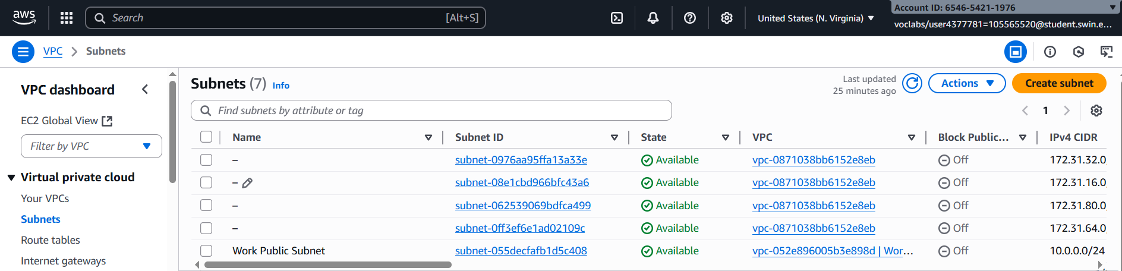
Figure 6: Subnets mainpage

11. Choose then configure:
- VPC ID: lab-vpc (select from the menu).
- Subnet name: lab-subnet-public2
- Availability Zone: Select the second Availability Zone (for example, us-east-1b)
- IPv4 CIDR block: 10.0.2.0/24
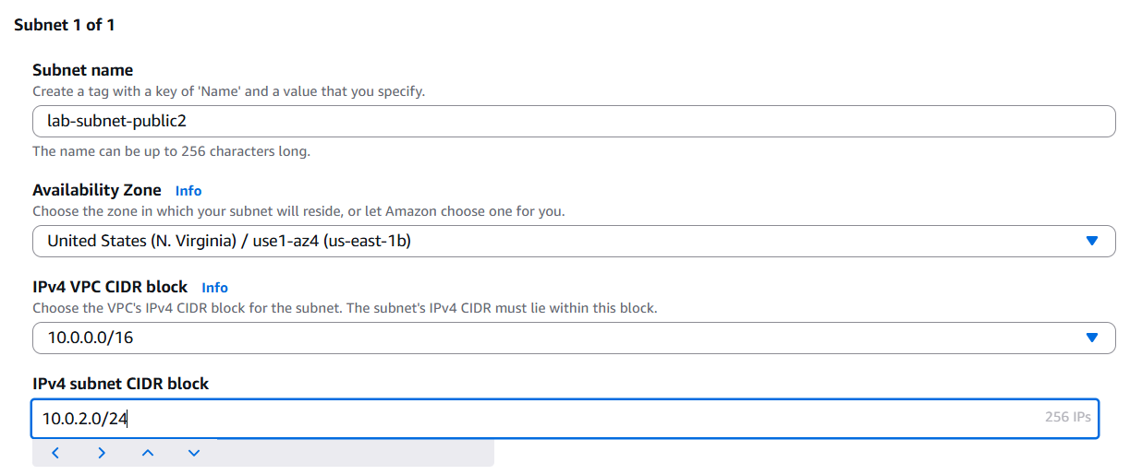
The subnet will have all IP addresses starting with 10.0.2.x.

Figure 7: Public subnet configuration


- Choose
The second public subnet was created. You will now create a second private subnet.

13. Choose then configure:
  - VPC ID: lab-vpc
  - Subnet name: lab-subnet-private2
  - Availability Zone: Select the second Availability Zone (for example, us-east-1b)
  - IPv4 CIDR block: 10.0.3.0/24
The subnet will have all IP addresses starting with 10.0.3.x
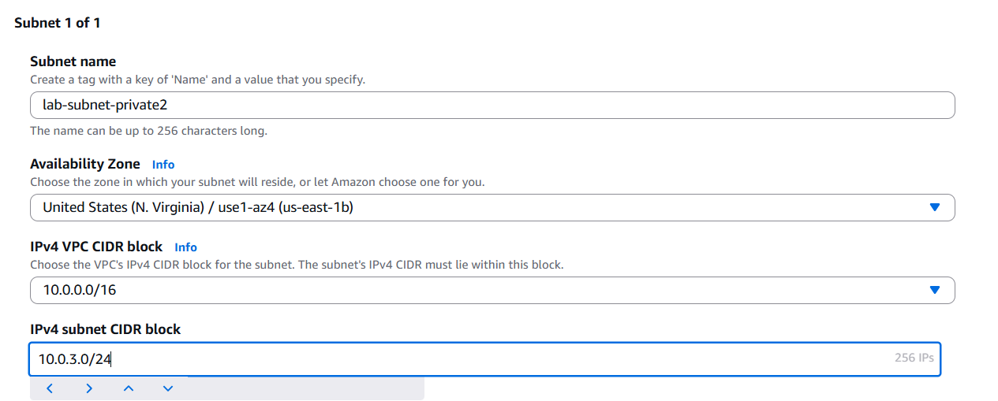
Figure 8: Private subnet configuration

14. Choose
The second private subnet was created.
You will now configure this new private subnet to route internet-bound traffic to the NAT Gateway so that resources in the second private subnet are able to connect to the Internet, while still keeping the resources private. This is done by configuring a Route Table.
A route table contains a set of rules, called routes, that are used to determine where network traffic is directed. Each subnet in a VPC must be associated with a route table; the route table controls routing for the subnet

15. In the left navigation pane, choose Route tables.

16. Select the lab-rtb-private1-us-east-1a route table.
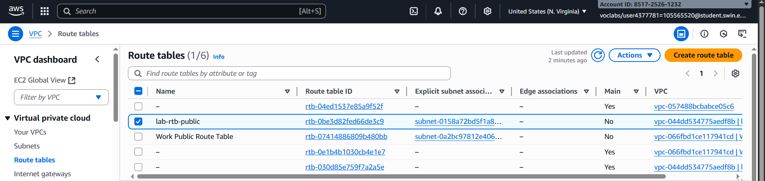
Note: If the newly created routes are not visible, choose refresh button at the top to update the list of routes.

Figure 9: lab-rtb-private1-us-east-1a selected

17. In the lower pane, choose the Routes tab.
Note that Destination 0.0.0.0/0 is set to Target nat-xxxxxxxx. This means that traffic destined for the internet (0.0.0.0/0) will be sent to the NAT Gateway. The NAT Gateway will then forward the traffic to the internet.
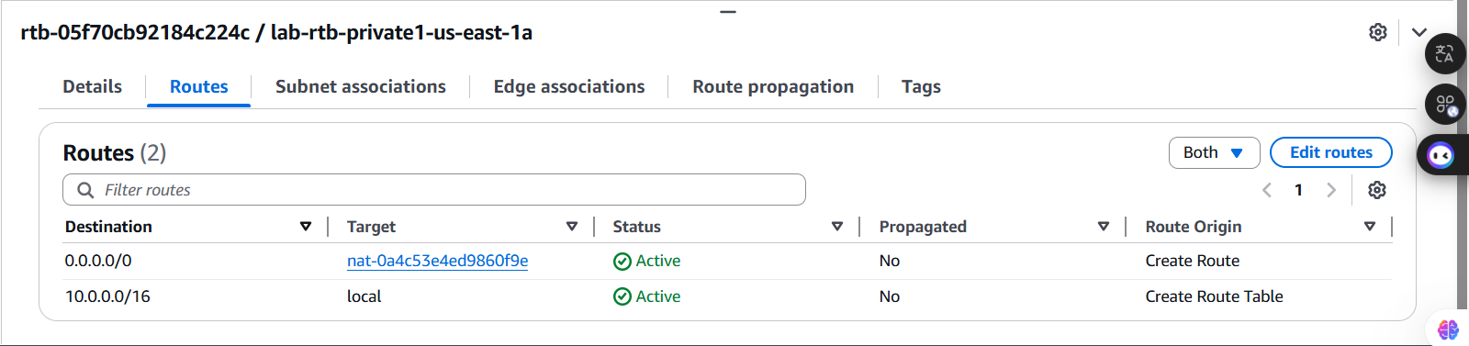
This route table is therefore being used to route traffic from private subnets.

Figure 10: Routes tab

18. Choose the Subnet associations tab.
You created this route table in task 1 when you chose to create a VPC and multiple resources in the VPC. That action also created lab-subnet-private-1 and associated that subnet with this route table.
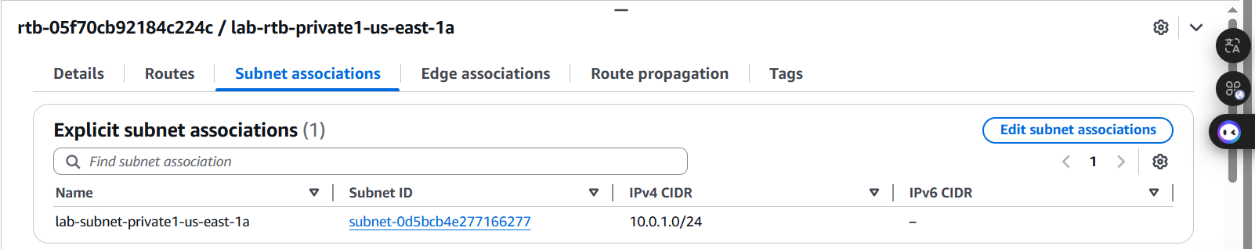
Now that you have created another private subnet, lab-subnet-private-2, you will associate this route table with that subnet as well.

Figure 11: Subnet associations tab

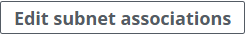
19. In the Explicit subnet associations panel, choose

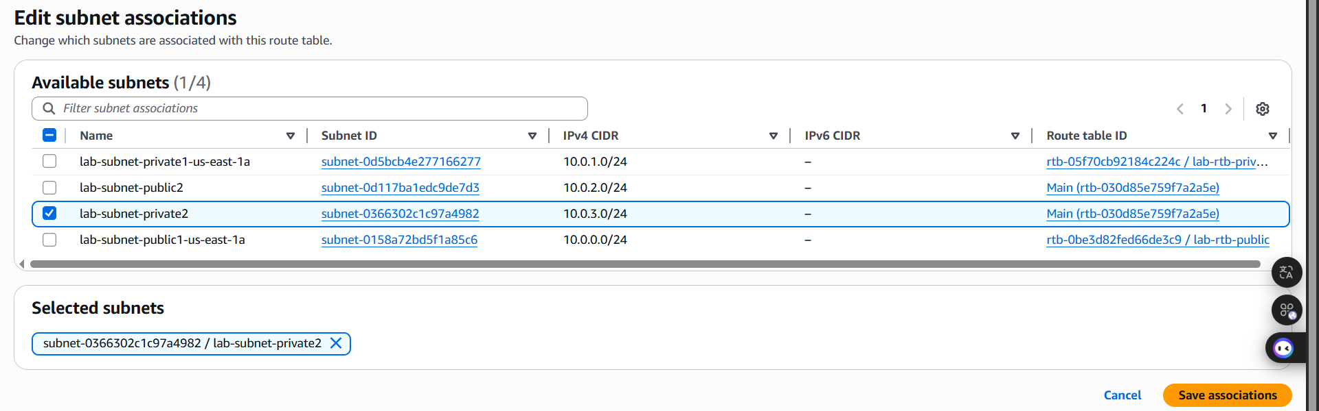
- Leave lab-subnet-private1-us-east-1a selected, but also select lab-subnet-private2.
Figure 12: Configuration changed
- Choose
You will now configure the Route Table that is used by the Public Subnets.

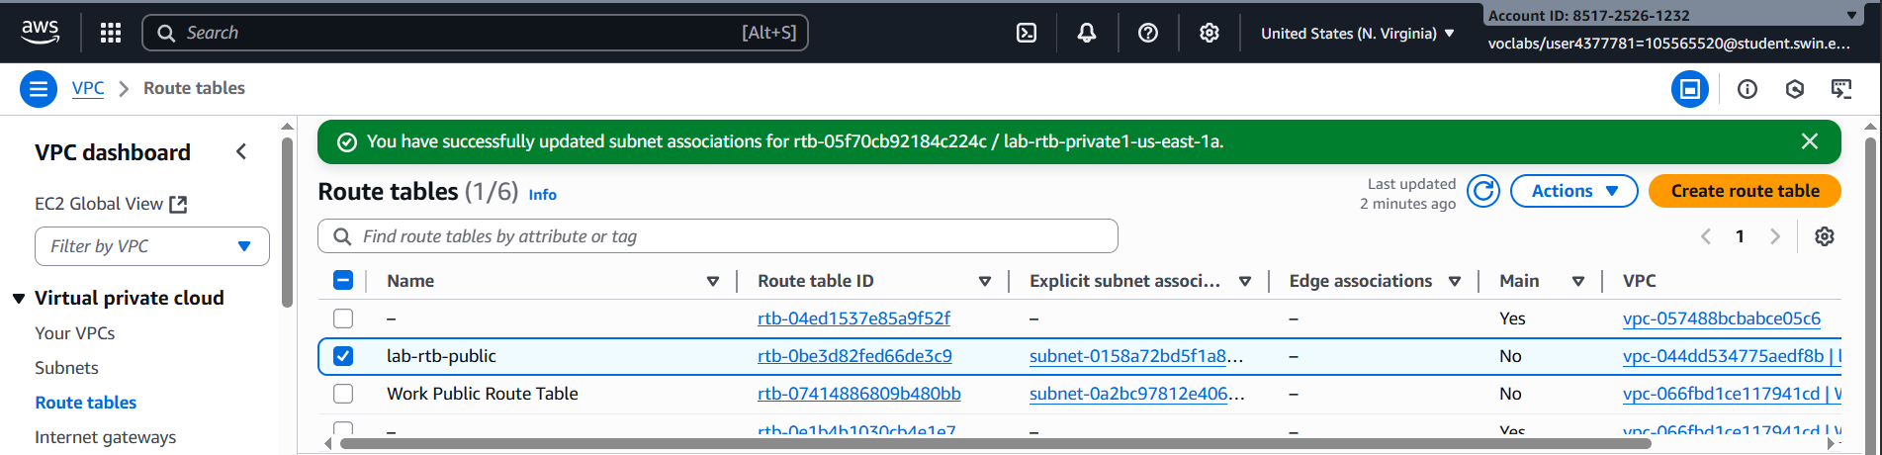
- Select the lab-rtb-public route table (and deselect any other subnets).

Figure 13: lab-rtb-public selected

23. In the lower pane, choose the Routes tab.
Note that Destination 0.0.0.0/0 is set to Target igw-xxxxxxxx, which is an Internet Gateway. This means that internet-bound traffic will be sent straight to the internet via this Internet Gateway.
You will now associate this route table to the second public subnet you created.

- Choose the Subnet associations tab.

- In the Explicit subnet associations panel, choose

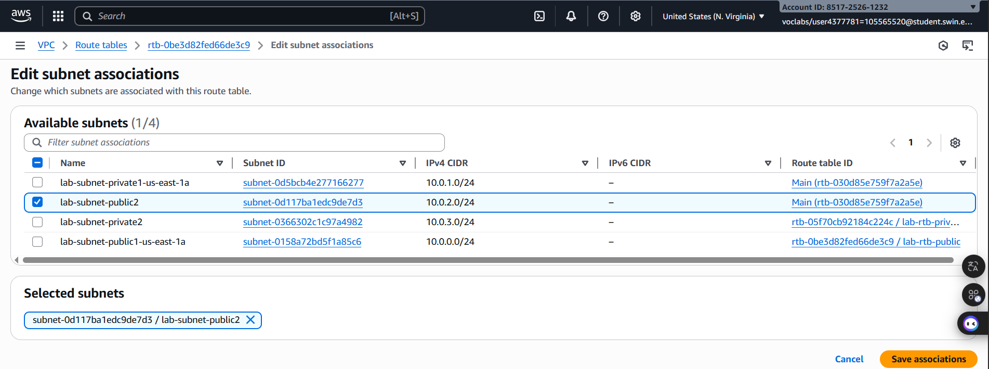
- Leave lab-subnet-public1-us-east-1a selected, but also select lab-subnet-public2

Figure 14: lab-subnet-public2 selected


- Choose
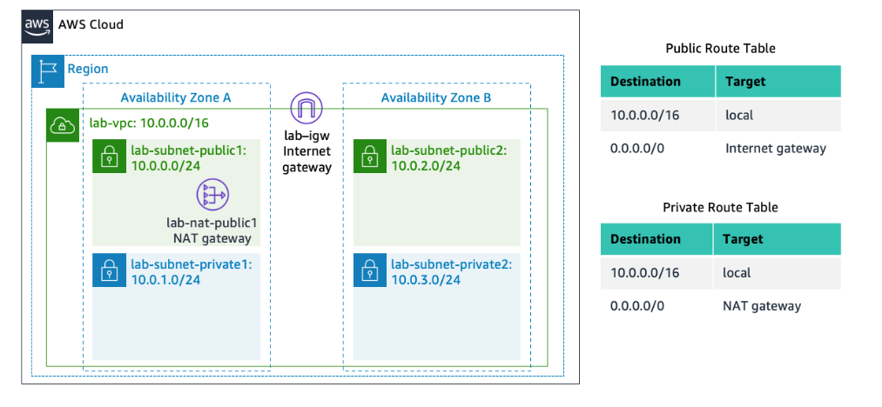
Your VPC now has public and private subnets configured in two Availability Zones. The route tables you created in task 1 have also been updated to route network traffic for the two new subnets.

D. Task 3: Create a VPC Security Group
In this task, you will create a VPC security group, which acts as a virtual firewall. When you launch an instance, you associate one or more security groups with the instance. You can add rules to each security group that allow traffic to or from its associated instances.

28. In the left navigation pane, choose Security groups.

- Choose and then configure:

- Security group name: Web Security Group
- Description: Enable HTTP access
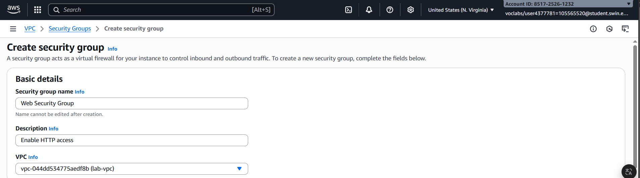
- VPC: choose the X to remove the currently selected VPC, then from the drop down list choose lab-vpc
Figure 15: Security groups configuration
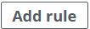
- In the Inbound rules pane, choose

- Configure the following settings:
- Type: HTTP
- Source: Anywhere-IPv4
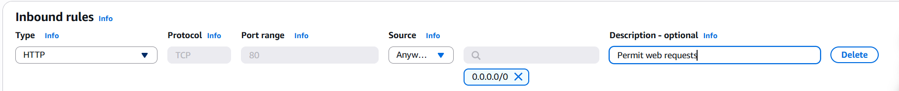
- Description: Permit web requests

Figure 16: Inbound configuration

32. Scroll to the bottom of the page and choose
You will use this security group in the next task when launching an Amazon EC2 instance.
E. Task 4: Launch a Web Server Instance
33. In the search box to the right of Services, search for and choose EC2 to open the EC2 console.


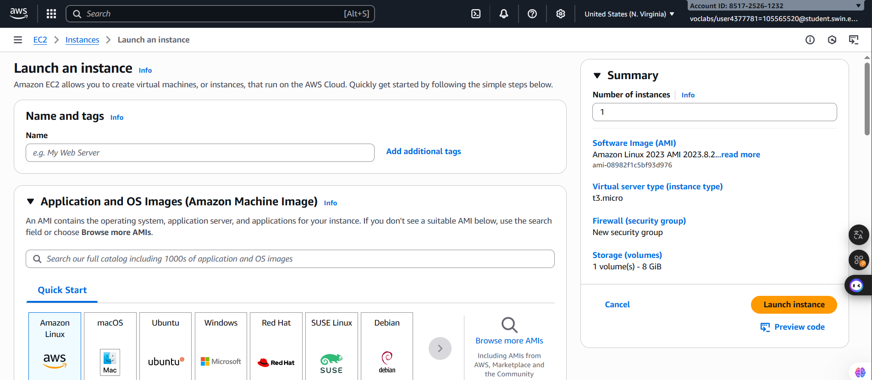
34. From the menu choose Launch instance.
Figure 17: EC2 Homepage

35. Name the instance:
- Give it the name Web Server 1
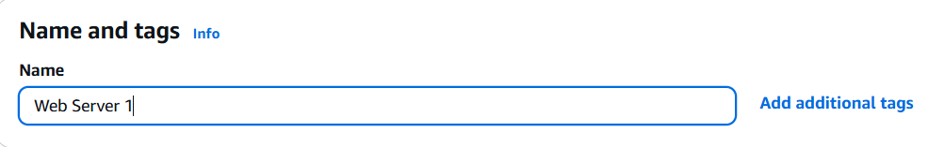
When you name your instance, AWS creates a tag and associates it with the instance. A tag is a key value pair. The key for this pair is *Name*, and the value is the name you enter for your EC2 instance.
Figure 18: Setting name for web server

36. Choose an AMI from which to create the instance:
  - In the list of available Quick Start AMIs, keep the default Amazon Linux selected.
  - Also keep the default Amazon Linux 2023 AMI selected.
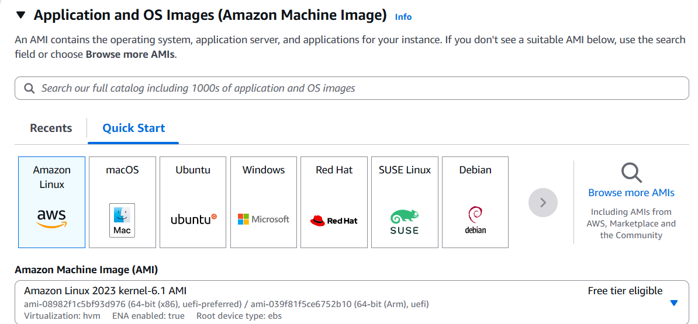
The type of Amazon Machine Image (AMI) you choose determines the Operating System that will run on the EC2 instance that you launch.

Figure 19: AMI Configuration

37. Choose an Instance type:
- In the Instance type panel, keep the default t2.micro selected.
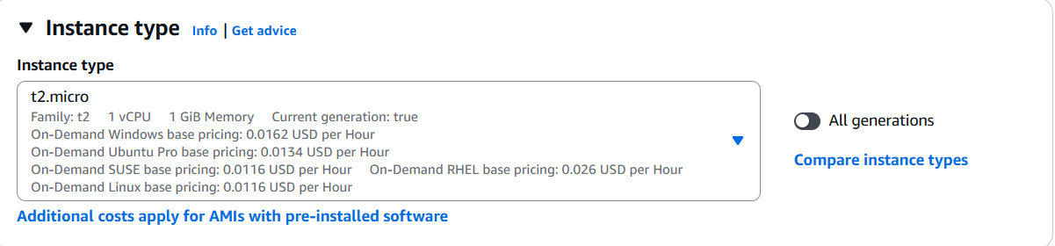
The Instance Type defines the hardware resources assigned to the instance.
Figure 20: Choose an instance type

38. Select the key pair to associate with the instance:
- From the Key pair name menu, select vockey.
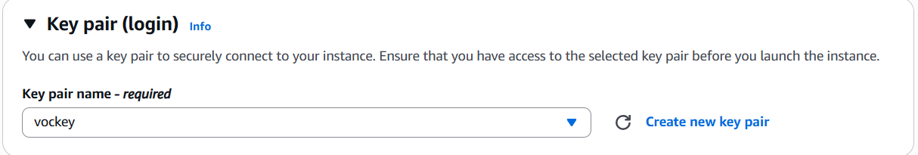
The vockey key pair you selected will allow you to connect to this instance via SSH after it has launched. Although you will not need to do that in this lab, it is still required to identify an existing key pair, or create a new one, or choose to proceed without a key pair, when you launch an instance.

Figure 21: Choose the key pair

39. Configure the Network settings:
- Next to Network settings, choose Edit, then configure:
  - Network: lab-vpc
  - Subnet: lab-subnet-public2 (not Private!)
  - Auto-assign public IP: Enable
- Next, you will configure the instance to use the Web Security Group that you created earlier.
  - Under Firewall (security groups), choose Select existing security group.
  - For Common security groups, select Web Security Group.
This security group will permit HTTP access to the instance.
Figure 21: Choose the key pair
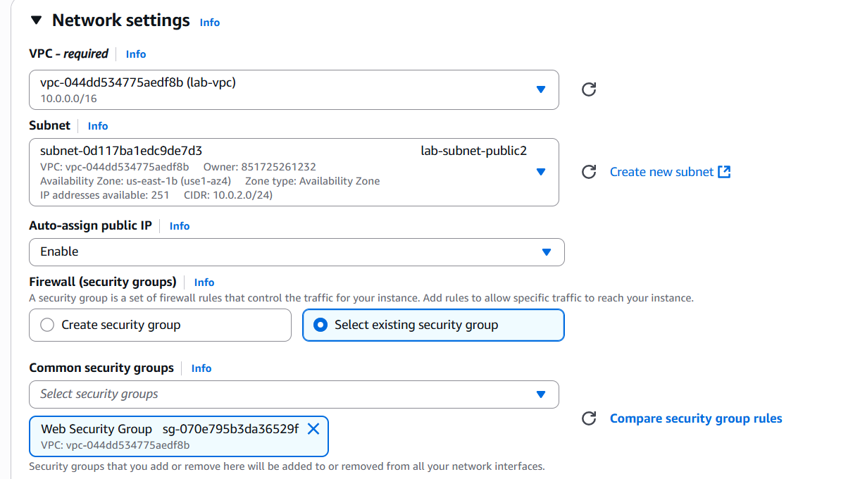
Figure 22: Network configuration

40. In the Configure storage section, keep the default settings.
Note: The default settings specify that the root volume of the instance, which will host the Amazon Linux guest operating system that you specified earlier, will run on a general purpose SSD (gp3) hard drive that is 8 GiB in size. You could alternatively add more storage volumes, however that is not needed in this lab.

41. Configure a script to run on the instance when it launches:
- Expand the Advanced details panel.
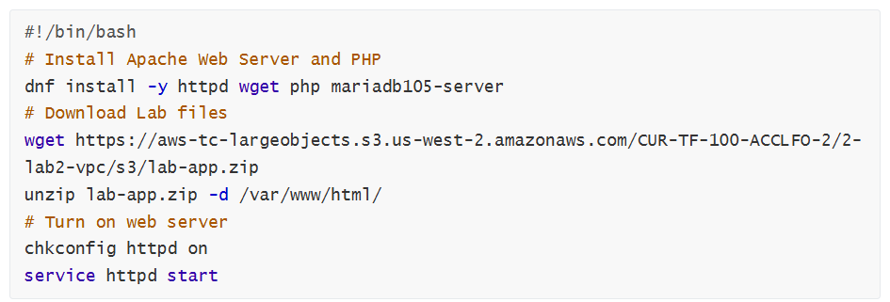
- Scroll to the bottom of the page and then copy and paste the code shown below into the User data box:
This script will run with root user permissions on the guest OS of the instance. It will run automatically when the instance launches for the first time. The script installs a web server, a database, and PHP libraries, and then it downloads and installs a PHP web application on the web server.
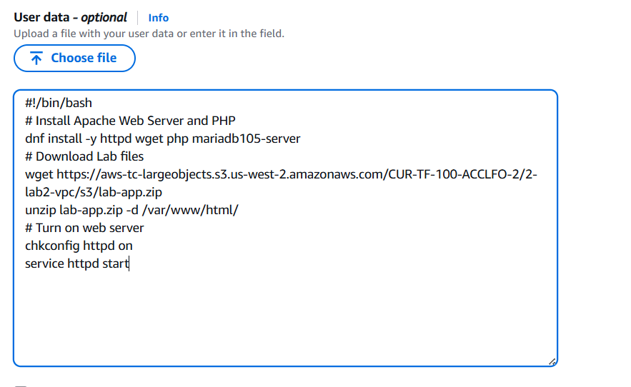
Figure 23: User Data Configuration

42. At the bottom of the Summary panel on the right side of the screen choose

You will see a Success message.
Figure 24: Launch instance successfully


43. Choose

44. Wait until Web Server 1 shows 2/2 checks passed in the Status check column.
This may take a few minutes. Choose the refresh icon at the top of the page every 30 seconds or so to more quickly become aware of the latest status of the instance.
You will now connect to the web server running on the EC2 instance.

- Select Web Server 1.

- Copy the Public IPv4 DNS value shown in the Details tab at the bottom of the page.

- Open a new web browser tab, paste the Public DNS value and press Enter.
You should see a web page displaying the AWS logo and instance meta-data values.
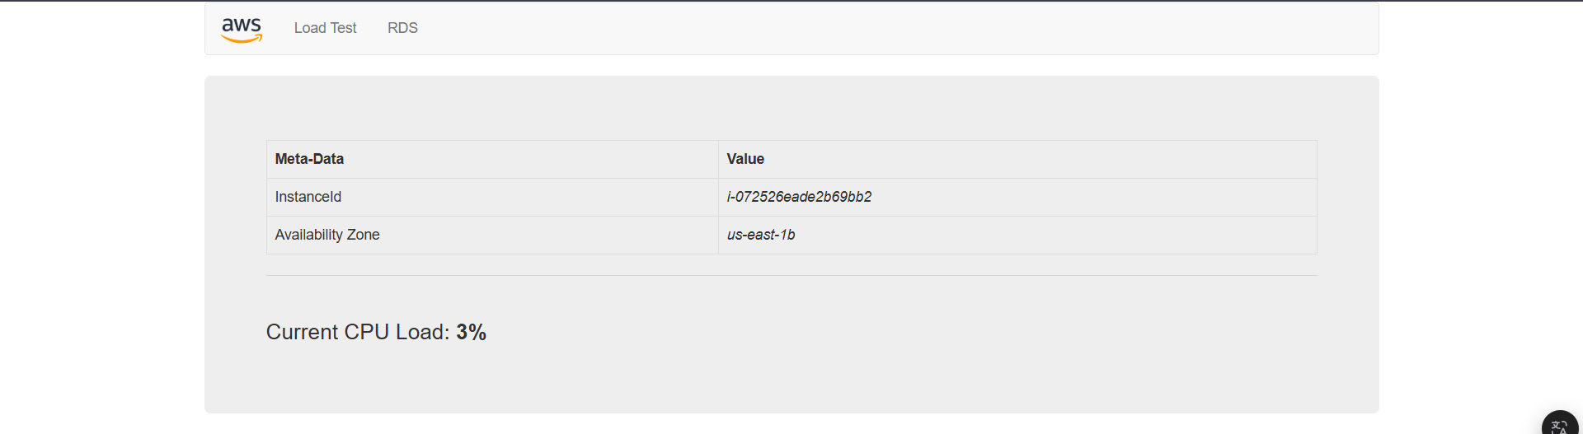
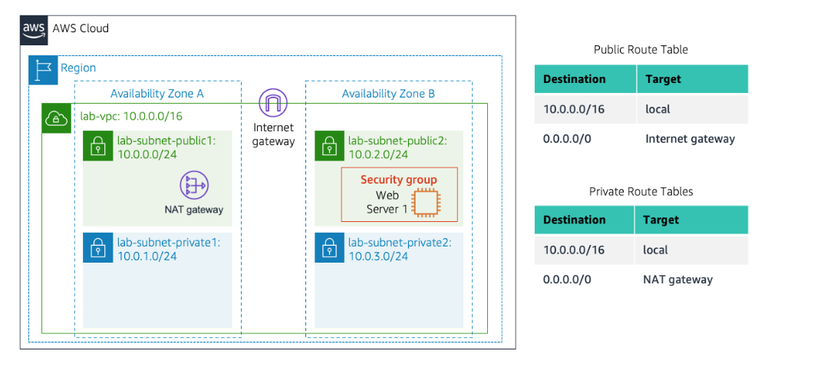
The complete architecture you deployed is:
Figure 25: Launch DNS address successfully

F. Submitting your work

- To record your progress, choose Submit at the top of these instructions.

Figure 26: Submit Confirmation

49. When prompted, choose Yes.
After a couple of minutes, the grades panel appears and shows you how many points you earned for each task. If the results don't display after a couple of minutes, choose Grades at the top of these instructions.

Tip: You can submit your work multiple times. After you change your work, choose Submit again. Your last submission is recorded for this lab.

50. To find detailed feedback about your work, choose Submission Report.
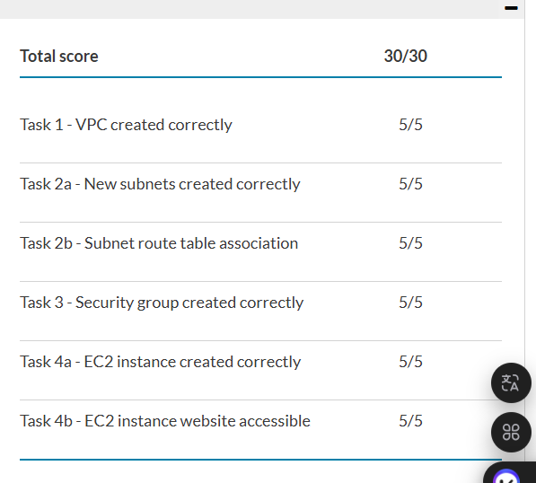
Tip: For any checks where you did not receive full points, there are sometimes helpful details provided in the submission report.
Figure 27: Lab completed

